OFFICIAL COORDINATION REQUEST FOR
NON-ROUTINE OPERATIONS AND MAINTENANCE

COORDINATION TITLE- 25JDA02 - Avian wire installation
COORDINATION DATE- 2/10/25
PROJECT- John Day Dam
RESPONSE DATE- 2/23/2025

Description of the problem – Last year USDA replaced 17 avian lines from the powerhouse section; they switched from vectran rope to stainless steel wire to improve the longevity of the lines. There are currently eight avian lines missing from the powerhouse section at John Day. USDA is planning on replacing the remaining 32 lines from the powerhouse section with stainless steel wire before the start of spring spill. The work is scheduled 24 February – 27 February. The South Fish Ladder (SFL) is scheduled to be returned to service on 27 February. On 24 February USDA will be taking down the lines that are still intact to prepare for the installation the following days. 25 February – 27 February will be the installation days of the new wires which will require the boat, at times, to be within 100ft of the SE-1 entrance to the South Fish Ladder (SFL).

Type of outage required – No outage required, the SFL will be operating in FPP criteria during this time.

Impact on facility operation – Operations will be coordinating with BPA, to have line outages (one line at a time) for the main units that the boat will be operating in front of to ensure the safety of everyone involved.

Dates of impacts/repairs – 25 February – 27 February

Length of time for repairs – 3 days

Analysis of potential impacts to fish – There should be minimal impacts to fish during this time. The boat will only be within the 100ft zone of the SE-1 entrance to the SFL for short periods of time during the 3-day period.

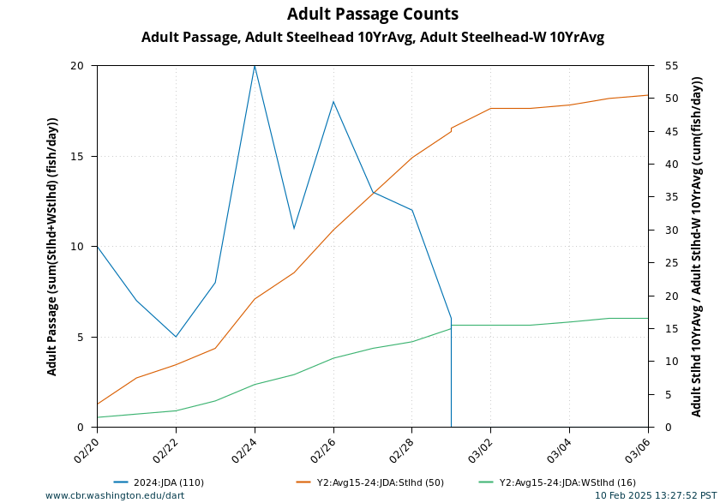

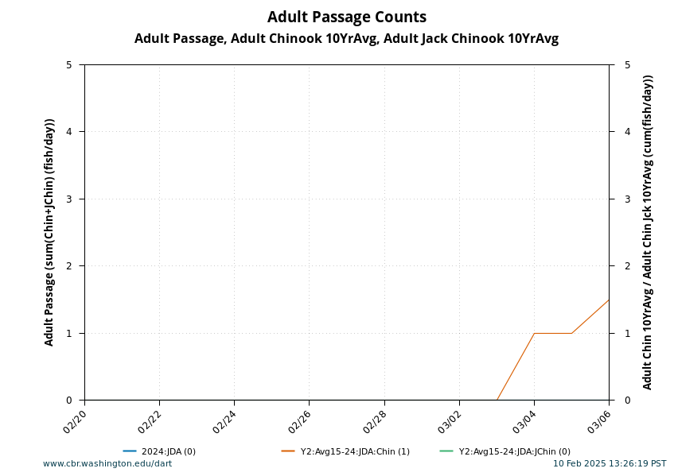

Summary statement – expected impacts on:

Downstream migrants: There is no expected impact to downstream migrants.

Upstream migrants (including Bull Trout): The entrance weirs and their entrances will be kept in FPP ranges.

Lamprey: The entrance weirs and their entrances will be kept in FPP ranges.

Comments from agencies

Final coordination results

Please email or call with questions or concerns.
Thank you,

David Miller
Supervisory Fisheries Biologist
John Day/Willow Creek Project
David.L.Miller@usace.army.mil

Patricia L. Madson
NWP Operations Division Fishery Section
Columbia River Coordination Biologist
Paticia.L.Madson@usace.army.mil

